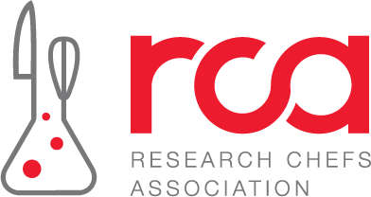

Meet Your Chairs: Chicagoland

The Meet Your Chair series continues, highlighting the dedicated volunteers who support connection, collaboration, and innovation across RCA’s regional network. Today, meet Nicole Linke and Jill Houk, your Chicagoland Regional Hub chairs!

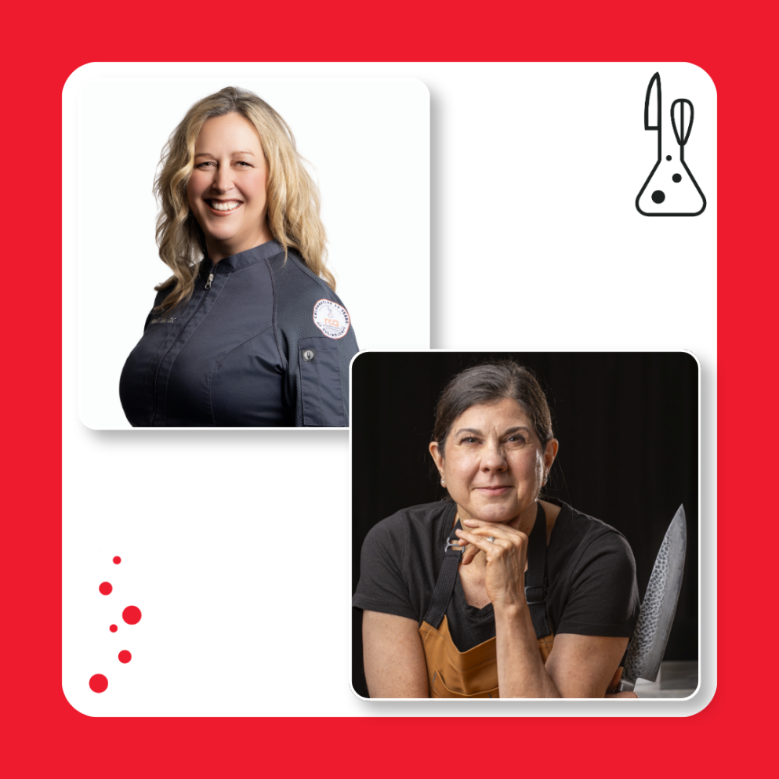

Nicole Linke, CRC
Nicole is a product development and innovation leader with more than 17 years of experience at The Suter Company. In her current role, she leads a team of four professionals in Product Development and Innovation, driving the creation of innovative food solutions while supporting strategic business growth across multiple industry channels.
In addition to her leadership responsibilities, Nicole plays a key role in Business Development through customer demonstrations, ideation sessions, and collaborative innovation initiatives with key customers in Grocery, Club, Foodservice, and other food industry segments. Her ability to connect culinary creativity with business strategy has helped foster long-term customer partnerships and growth opportunities.
Nicole has been an active member of the Research Chefs Association (RCA) since 2018 and earned her Certified Research Chef (CRC) designation in October 2021. Deeply committed to the RCA's mission and future, she joined the Executive Committee as Secretary in 2024 and remains passionate about advancing the organization, supporting its members, and strengthening its impact across the food industry.
Beyond her national leadership involvement, Nicole has been highly engaged with the Chicagoland Regional Committee, regularly participating in events and contributing to strong member engagement and community building. She believes in the importance of leadership development, succession planning, and organizational continuity, and views the progression from board member to Secretary, Vice President, and President as a valuable pathway for sustaining strong leadership within the RCA.
Nicole is honored to serve the RCA and is excited to continue contributing to the organization's growth, success, and future leadership as Regional Chair.

Jill Houk, CRC
Jill is the Corporate Research and Development Chef at Culinary Culture, a culinary consultancy. Originally pursuing a career in information technology, Jill mixes the research and data analysis skills practiced in information technology with the knowledge of flavors, cooking techniques, and consumer dining trends that she's learned in her 20 years as a chef. In her current role, she creates gold standard applications for food manufacturers and foodservice operators.

Jill joined the RCA in 2017 and has been a member of the Chicagoland Regional Committee, organizing local events and attending as many events as she can. She is also active nationally as co-chair of the NBDC. Jill has appeared on Good Morning America and The Cooking Channel and is the author of two cookbooks.

Get involved with your RCA region!

No matter where you’re located, now is the perfect time to connect with your local RCA community. Visit your region’s page to learn about your leadership, explore upcoming events, and find opportunities to get involved. Your next valuable connection or learning opportunity could be just around the corner.

Explore RCA Regions

View the Event Calendar

