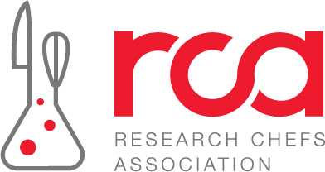
Get to Know the 2027 RCA Board Candidates
There are thirteen (13) candidates for the 2027 RCA Board. You can vote for no more than eight (8) candidates. From the thirteen candidates on the slate, the eight candidates who receive the most number of votes will be seated on the 2027 RCA Board of Directors, beginning Spring 2027.

Scroll down or click to review candidate profiles:

Gregg Brickman
Howard Cantor
Frank Carrieri
Anna Cheely
Rich Hammerschlag
Zachary Kelly
Sam Kressler
Ben Lee
Mickey Miller
Chris Moyer
Laurie Neff
Casey Schallert
Cara Watkins

When ready, return here to submit your vote: https://culinology.memberclicks.net/board-voting-form
Note: Changes cannot be made once you’ve submitted your ballot. Please be sure about your selections before you submit your vote.

Gregg Brickman
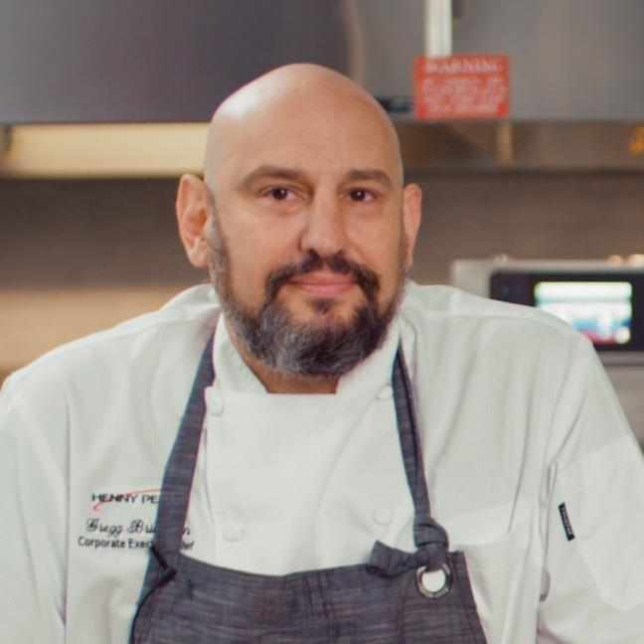
Vision Statement
I joined RCA because I knew there was a lot I did not know. I was moving deeper into product
development and wanted to learn from people who had already made that transition and understood the challenges, systems, and opportunities that come with it. RCA gave me access to people willing to share experience, challenge thinking, and help me grow.

Since then, I have served on the Student Competition and Conference Committees, currently serve on Certification, James Beard/Charlie Trotter, and Conference, and have served as Treasurer and now President. That experience has given me a clear view of where RCA is strong and where we need more structure.

My focus for the next term is execution and sustainability. We need stronger processes and procedures for incoming Executive Board members so leadership transitions do not depend on tribal knowledge. We also need to broaden RCA's reach into areas that are part of modern product development but may not always see themselves represented - including beverage, bakery, and other specialized disciplines.

I also want to keep pushing the future of our events, charitable work, and member education. The goal should be to create more reasons for members to engage throughout the year, not just at conference, while building stronger connections among industry, education, certification, and the next generation of Culinology professionals.

I bring an operator's mindset, culinary leadership, product development experience, and hands-on board experience. I am not interested in maintaining something simply because that is how it has always been done. I want to help RCA build stronger systems, expand its relevance, and leave the organization better positioned for the leaders who come next.

Personal Bio
Gregg Brickman is Corporate Executive Chef / Sr. Director of Culinary at Zaxby's, where he leads culinary innovation and product development focused on creating scalable, consumer-relevant products that can be executed across a national restaurant system.
He has more than 20 years of culinary and foodservice leadership experience spanning restaurant operations, culinary innovation, equipment and application development, and commercialization. Prior to Zaxby's, Gregg served as Corporate Executive Chef / Manager of Culinary Services for Henny Penny, working with restaurant brands and operators on product testing, program development, equipment application, and training. Earlier, he served as Sr. Director of Culinary Innovation for HOA Brands, supporting Hooters and Hoots Wings and leading the development, testing, and launch of culinary products across a global restaurant system. His background also includes leadership with Wolfgang Puck Catering, where he worked in high-volume and high-profile culinary operations.
Gregg studied Culinary Arts at Johnson & Wales University. His professional memberships include ICCA, the National Restaurant Association, and the American Culinary Federation.
Within the Research Chefs Association, Gregg has served on the Student Competition and Conference Committees and currently serves on the Certification, James Beard/Charlie Trotter, and Conference Committees. He has served as RCA Treasurer and currently serves as President.
His board approach is practical and execution-focused: build clear systems, improve leadership continuity, expand RCA's relevance across a broader range of product-development disciplines, strengthen education and member engagement, and create a stronger foundation for the organization's future.

Howard Cantor
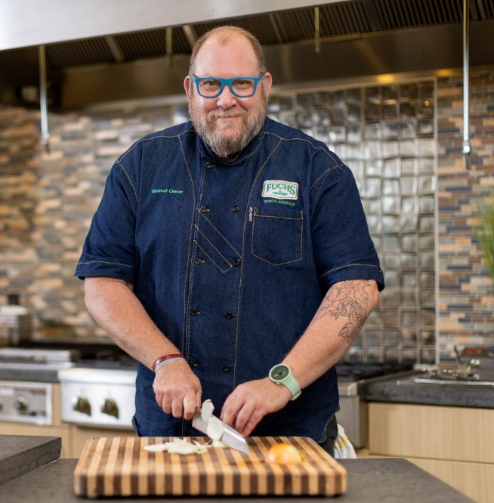
Vision Statement
My passion for the Research Chefs Association started almost 20 years ago has always been rooted in the belief that our greatest strength lies in the connection between culinary arts, food science, and the next generation of industry professionals. As I seek re-election to the RCA Board of Directors, I want to continue building on the progress we have made while helping shape an even stronger future for our organization. One of the most rewarding aspects of my involvement has been working directly with colleges, culinary programs, and students across the country, helping bridge the gap between education and real-world opportunities in Culinology®. Through mentoring, classroom engagement, and professional guidance, I have made it a priority to help students understand the diverse career paths available to them and develop the confidence to pursue those opportunities. That same passion has driven my work to refresh and reinvigorate both the Student and Professional Culinary Competitions, creating experiences that better reflect today's industry while encouraging creativity, innovation, and collaboration. Moving forward, I am equally committed to transforming our Mixology Competition to align with the look, feel, and professional standards of our culinary competitions, creating a cohesive and exciting competitive platform that strengthens the RCA conference experience for students, professionals, and industry partners alike.
Equally important to me has been my responsibility as RCA Treasurer and my commitment to ensuring the organization's financial health and long-term sustainability. Working alongside fellow Board members and RCA leadership, I have focused on helping move the organization toward greater financial stability, responsible stewardship of our resources, and a stronger foundation for future growth. While financial stability has been an essential priority, I believe our next chapter must focus on turning that stability into opportunity—expanding member value, strengthening industry partnerships, growing student engagement, and developing programs that attract and retain the next generation of Culinology professionals. My vision is for the RCA to be more than a professional association; I want it to be a driving force in culinary innovation, education, mentorship, and career development. I am seeking another term on the Board not simply to continue the work we have started, but to help ensure that the progress we have made becomes lasting momentum. We have worked hard to strengthen the foundation of the RCA. Now it is time to build on that foundation and position the organization for meaningful, sustainable growth for years to come.
Personal Bio
Howard Cantor is the Corporate Executive Chef for The Fuchs Gruppe, where he leads culinary innovation, product development, and customer-focused concept creation across North America. With more than 30 years of experience spanning professional kitchens, food manufacturing, culinary R&D, and commercial product development, Howard has built his career around connecting the creativity of the chef with the science and discipline required to bring successful food products to market.
Throughout his career, Howard has collaborated with chefs, food scientists, product developers, marketers, and customers to develop innovative flavor systems, seasonings, sauces, proteins, and finished-product concepts. His approach combines culinary craftsmanship with sensory evaluation, flavor architecture, consumer trends, benchmarking, and commercialization.
Howard is an active leader within the Research Chefs Association and the American Culinary Federation. He is a passionate advocate for Culinology®, culinary education, mentorship, and developing the next generation of research chefs, chefs and food scientists.
Whether working in the kitchen, collaborating with R&D teams, mentoring students, or serving one of the organizations membership, Howard’s philosophy remains simple: bring chefs and scientists together, challenge conventional thinking, and turn great culinary ideas into meaningful innovation.

Frank Carrieri
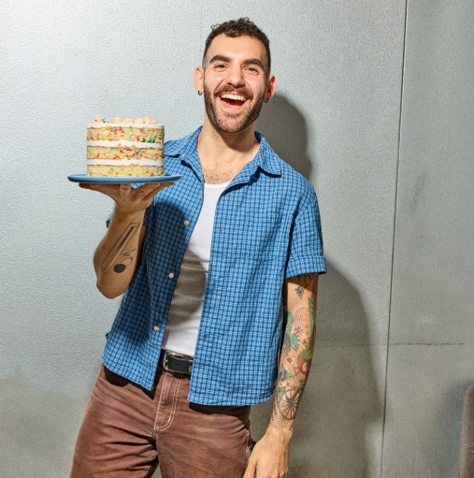
Vision Statement
I discovered the impact of true food innovation when a product I helped develop didn’t just meet a brief, it changed how people experienced a familiar ingredient. That mix of creativity, consumer insight, and teamwork is exactly what excites me about our industry.
I transitioned from working as a pastry chef in hotels and restaurants to R&D in 2020. Like many chefs who pivoted in their careers, I was nervous. I could move through a kitchen with grace, but could I talk shop with research chefs or food scientists? I joined the RCA because I wanted to connect with other chefs who had stories like mine and learn from the diverse paths within our industry. When I attended the 2024 Annual Conference, I was inspired by the unique backgrounds of the people in the room who all shared a common interest in food.
As a pastry chef working in R&D, I quickly realized that there were few people whose career paths I could look to as a model. I had to find my own direction and build a career that connected my culinary background with food science, product development, and commercialization.
Over the last few months as R&D Director at Milk Bar, I have been approached by pastry chefs who are inspired to make a similar transition. That has reinforced for me how important representation and mentorship can be when someone is considering a career path they have not seen modeled before.
As a member of the Board of Directors, I would bring a unique perspective shaped by both professional kitchens and R&D. I hope to help strengthen the connection between culinary professionals and the broader research and development community, while encouraging chefs from nontraditional backgrounds to see themselves as part of the RCA.
I am uniquely qualified to serve because I understand both sides of that bridge. My experience leading R&D, product commercialization, and cross-functional teams, has taught me how to turn culinary ideas into scalable products while keeping creativity at the center. I want to use that experience to contribute to the RCA, support its members, and help create more opportunities for the next generation of chefs and food professionals.
Personal Bio
Frank Carrieri is the Director of R&D and Product Commercialization at Milk Bar, where he leads the end-to-end development and commercialization of products from concept through scalable production. His work bridges culinary innovation, technical R&D, operations, and business strategy, providing him with a broad perspective on the food industry and the evolving role of the research chef.

Frank earned a B.S. in Baking & Pastry Arts and Food Service Management from Johnson & Wales University and an M.A. in Gastronomy from Boston University, where his research explored the cultural significance of French desserts through cookbooks. His academic background, combined with extensive industry experience, has shaped his approach to food as both a creative discipline and a field grounded in research, history, and innovation.

His culinary career includes experience at leading organizations such as the Beverly Wilshire, A Four Seasons Hotel, and Ladurée. Prior to Milk Bar, Frank served as Senior Chef of Chocolate & Cocoa Applications at Barry Callebaut, traveling across North America to lead product development, culinary demonstrations, and educational seminars. He collaborated with major brands including Mondelēz, Chobani, Pepperidge Farm, Grupo Bimbo, and The Magnum Ice Cream Company, helping teams translate technical ingredients and concepts into innovative products and applications.

At Milk Bar, Frank manages cross-functional product development and commercialization, balancing creativity with quality, food safety, cost, supply chain, and operational execution. He is a Certified Research Chef (CRC) and brings expertise in culinary R&D, product development, commercialization, project leadership, education and training, cross-functional collaboration, and industry partnerships.

Frank is passionate about advancing the research chef profession and strengthening the connection between culinary creativity, science, technology, and business. He would bring the RCA Board a combination of hands-on culinary experience, technical R&D expertise, academic perspective, and experience collaborating across diverse areas of the food industry. He is committed to supporting the RCA community, expanding educational opportunities, and helping develop the next generation of Culinologists.

Anna Cheely
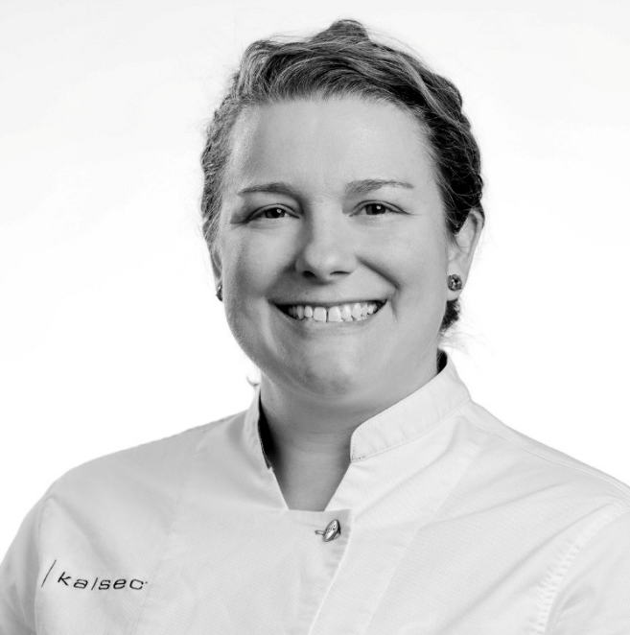
Vision Statement
When I first wrote my RCA vision statement several years ago, my focus was primarily on the opportunities the organization created for individual members like myself. As my involvement with RCA has grown through volunteer leadership, committee work, Board service, and my current role as Vice President, my perspective has evolved as well. Today, while I remain deeply committed to connection, mentorship, and member engagement, I also recognize the importance of organizational stewardship, advocacy, and preparing RCA for the future.
My journey with the Research Chefs Association began with a search for connection. As a chef entering the world of food science, I found a community willing to share knowledge, encourage growth, and help individuals discover their place within our profession. The relationships and experiences I gained through RCA have profoundly influenced my career and reinforced the value of bringing together diverse perspectives in pursuit of a common goal.
My vision for RCA is centered on thoughtful growth, meaningful impact, and longterm sustainability. As our industry continues to evolve, RCA has an opportunity not only to serve its members but also to advocate for the profession of Culinology and expand awareness of the unique value our members bring to the food industry.
I believe the strength of RCA lies in its people. To remain vibrant and relevant for future generations, we must continue creating opportunities for members to connect, contribute, and grow throughout every stage of their careers. This includes developing leadership pathways, supporting volunteers, fostering mentorship, and intentionally preparing future leaders to carry the organization forward.
Equally important is our responsibility to strengthen RCA's reach and influence. By elevating the visibility of Culinology, building partnerships across the food industry, and sharing the expertise that exists within our membership, we can continue to grow awareness of the profession while creating value for members, students, educators, and industry partners alike.
My commitment is to help RCA remain a welcoming, forward-thinking organization that balances innovation with stewardship. Through mindful leadership, volunteer development, advocacy, and succession planning, we can ensure RCA continues to thrive while preparing the next generation to lead with confidence and purpose.
Personal Bio
Anna Cheely is Senior Culinary Innovation Manager at Kalsec, where she leads culinary innovation initiatives that connect consumer insights, ingredient technologies, and culinary expertise to deliver meaningful solutions for customers around the world. Throughout her career, she has worked at the intersection of culinary arts and food science, helping organizations translate ideas into commercially relevant food experiences. Her work spans concept development, sensory insight, culinary strategy, and cross-functional collaboration.

An active volunteer and leader within the Research Chefs Association, Anna currently serves as Vice President and has contributed to the organization through board service, membership engagement initiatives, regional support, and leadership development e􀆯orts. She is passionate about fostering meaningful connections among chefs, food scientists, students, educators, and industry professionals while advocating for the value and visibility of Culinology across the food industry.

Anna believes strong organizations are built through thoughtful leadership, engaged volunteers, and intentional investment in future leaders. She is committed to helping RCA grow its reach, develop sustainable leadership pathways, and create opportunities for members to learn, contribute, and thrive throughout their careers.

Outside of work, Anna enjoys exploring the intersection of food, culture, and human connection. Whether through travel, shared meals, or conversations around the table, she is inspired by the stories, traditions, and ingredients that bring people together.

Rich Hammerschlag
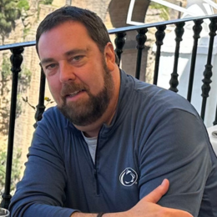
Vision Statement
Throughout my career, I have been passionate about helping food companies identify innovative ingredient solutions that enable successful product development and commercialization. As President of Accurate Ingredients, Inc., I have had the opportunity to work closely with chefs, food scientists, research and development teams, manufacturers, and ingredient suppliers across multiple food categories. These experiences have reinforced my appreciation for the unique role the Research Chefs Association plays in bringing culinary and food science professionals together through the discipline of Culinology®.
My involvement in the food industry has demonstrated the importance of collaboration, education, and innovation. RCA provides an invaluable platform for sharing knowledge, fostering professional development, and creating meaningful industry relationships. I believe the organization's strength lies in its ability to unite diverse expertise to solve challenges and drive product innovation.
If elected to the Board of Directors, I will focus on strengthening member engagement, expanding industry partnerships, supporting membership growth, and promoting the value of Culinology® throughout the food industry. I am particularly interested in helping RCA enhance opportunities for emerging professionals, increase supplier and manufacturer participation, and strengthen educational programming that supports members throughout their careers.
My professional background provides a broad perspective on the needs of ingredient suppliers, manufacturers, product developers, and customers. Through years of leadership, strategic planning, business development, and technical sales, I have developed the ability to build consensus, create relationships, and identify opportunities that benefit multiple stakeholders.
I am committed to serving RCA with integrity, professionalism, and enthusiasm. As a Board member, I will actively support the association's mission, contribute strategic insights, and work collaboratively with fellow Board members, volunteers, and staff to ensure RCA remains a strong, relevant, and growing organization for future generations of Culinology professionals.
Personal Bio
Richard Hamerschlag is President of Accurate Ingredients, Inc., where he leads the company's efforts in ingredient sourcing, customer development, strategic growth, and innovation support for food manufacturers across North America.
With extensive experience in the food ingredient industry, Richard has dedicated his career to connecting manufacturers with ingredient solutions that improve product quality, functionality, consumer appeal, and operational performance. His expertise includes business development, strategic sales, product development support, ingredient functionality, commercialization, and customer relationship management.
Throughout his career, Richard has collaborated closely with research and development teams, culinary professionals, food scientists, operations leaders, and executive management to help bring innovative food products to market. His broad industry perspective enables him to understand the challenges faced by both suppliers and manufacturers while identifying opportunities for growth and collaboration.
As President of Accurate Ingredients, Richard has built strong partnerships throughout the food industry by emphasizing technical expertise, integrity, responsiveness, and customer-focused solutions. He is recognized for his ability to translate complex ingredient technologies into practical applications that help customers succeed in competitive markets.
Richard is a strong advocate for professional development, industry education, and mentorship. He believes that the future success of the food industry depends on continued collaboration between culinary arts and food science, making the mission of the Research Chefs Association especially meaningful.
His leadership style is centered on collaboration, accountability, strategic thinking, and service. Through service on the RCA Board of Directors, Richard hopes to leverage his industry experience, professional network, and passion for innovation to support the association's strategic objectives, expand member value, strengthen industry partnerships, and promote the growth of Culinology®.
Richard is honored to be considered for service on the RCA Board of Directors and looks forward to contributing to the organization's continued success and impact within the food industry.

Zachary Kelly
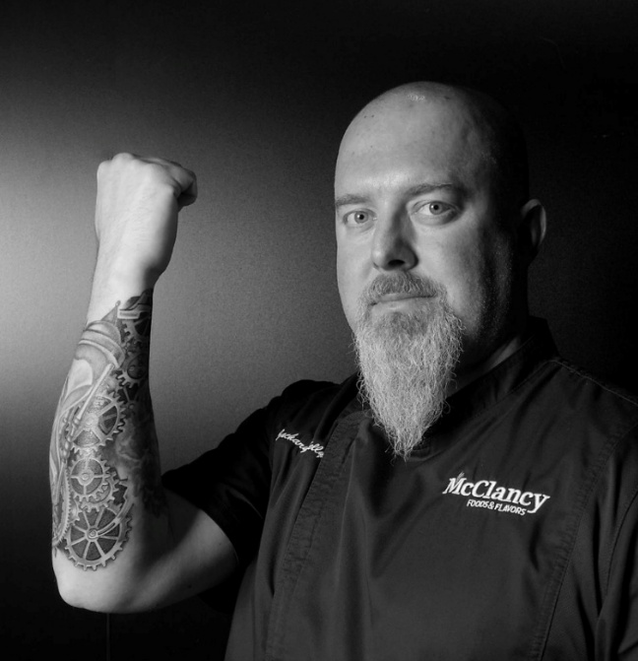
Vision Statement
I’ll be honest: I was initially skeptical about joining the Research Chefs Association. I wasn’t convinced the organization was actively driving the industry forward in the ways that mattered most to me. However, a respected mentor challenged me to step into the fold and help push the organization forward from the inside. I took his advice and never looked back. Through my involvement in national conferences and regional chapters, I quickly realized the immense power of this network—a space where culinary artistry and food science truly intersect. Having seen its potential firsthand, I am ready to help shape the RCA's future on the Board of Directors.
My vision for the RCA centers on building a robust, intentional bridge between young culinary professionals and the manufacturing sector. When I graduated from the Culinary Institute of America, I believed my career would be defined entirely by the four walls of a traditional kitchen. I had no idea the manufacturing side even existed, let alone how deeply it relies on true culinary arts to scale authentic flavors successfully. We cannot wait for young chefs to stumble into Culinology by accident. To secure our future and grow our membership, the RCA must go directly to college campuses, actively engage the youth, and prove the tangible value of a career in commercialization. We need to show them that taking a recipe from a five-quart mixer to a 5,000-gallon kettle isn't a departure from the kitchen—it is the ultimate culinary challenge.
When considering my qualifications, I believe humility is just as important as experience. No single person has all the answers; true progress happens when professionals come together through healthy debate and strategic collaboration. Over my 25-year career, I have navigated the full spectrum of our industry—from serving as an Executive Chef, to Director of Innovation, and now as Senior Manager of Culinary Sales. I understand both the creative grit required to develop complex formulations and the business acumen needed to sell them. If elected, I will bring this holistic perspective to the Board, championing the strategic teamwork required to empower the next generation and push the RCA boldly into the future.

Personal Bio
Zachary Kelly is a culinary professional and strategic leader with over 25 years of experience bridging the gap between authentic culinary arts and commercial food science. His journey began at age 15, and his foundational skills were forged in the demanding kitchens of Aspen’s Little Nell and Hotel Jerome. A 2008 graduate of the Culinary Institute of America, Zachary brings a grounded, “zen-like” focus to high-pressure environments—a trait that has served him well from the Friday night line to the corporate boardroom. Throughout his early career as an Executive Chef, he honed a deep appreciation for diverse global flavor profiles, ranging from Provençal and Basque to Latin American and Asian cuisines.
Transitioning into commercial manufacturing, Zachary has spent the last decade mastering the discipline of Culinology. His track record of success is defined by exceptional product longevity: multiple SKUs he formulated nearly a decade ago at Bakkavor USA remain staples on the shelves of Trader Joe’s today. This sustained success highlights his deep understanding of vertical manufacturing processes and his ability to navigate fickle consumer trends. His technical expertise spans shelf-stable, refrigerated, and freeze-thaw formats, with a strong focus on complex hot-pack sauces, cold-pack emulsions, and cutting-edge, allergen-conscious formulations.
Having guided cross-functional teams as Director of Innovation at McClancy Foods & Flavors, Zachary now serves as Senior Manager of Culinary Sales at Legacy Foods Manufacturing LLC. In this capacity, he maintains his R&D edge while driving high-level corporate sales strategy. He leverages a robust national network of renowned chefs and corporate executives to align culinary innovation with strategic business growth, developing custom product briefs and commercial flavor profiles for major national accounts like The Habit Burger Grill and Reser’s Fine Foods.
Zachary views the culinary arts through the lens of a painter. A chef creates a beautiful, original masterpiece; scaling a product for manufacturing is the meticulous process of making flawless "prints" of that original work. However, to thrive in this industry, one must never stop learning and must constantly strive to create new original art. Zachary is an exceptional candidate for the RCA Board of Directors because he embodies this philosophy. He seamlessly navigates both the artistic soul of the kitchen and the strategic realities of commercial sales, making him uniquely equipped to help lead the RCA into its next chapter of innovation.

Sam Kressler

Vision Statement
When I was elected to the RCA Board nearly two years ago, I had been a paid member for less than four months. I had virtually no connection to the organization. I only knew that it was a unique community of misfits, that resonated with me as a place I might be able to fit in professionally and culturally. I am SO grateful that my instincts were so spot on.
In the past two years, I have come to deeply appreciate the people and culture that make the RCA such a special community within our industry. Having served as the Chair of the Annual Conference Committee for the past two years, I have been able to support the RCA’s membership by working with the committee members, as well as the rest of the Board, to bring to life two of the most successful Annual Conferences (both in terms of attendance and revenue) in the past decade, if not the RCA’s history. Yes, this event showcases the vendors who support our brands, thought leaders that push our industry forward, and flavors at the bleeding edge of innovation. But what I saw as a first-timer in St. Louis and again, a bit more seasoned, in my own backyard in Westminster, was so much more than that.
We have such a unique and thriving community, based more on friendships and shared values than on “closing the deal.” A space like ours is rare in this world, especially in professional circles. If reelected to the Board, my goal is to continue building our membership, growing our voice and influence throughout the CPG industry, especially in the natural products space where much of the newest culinological CPG innovation takes place, serving as an ambassador for the RCA and the discipline of Culinology, and finding and implementing new programs within the RCA to provide additional, meaningful value to our membership.
The friendships and community I have gained over the past two years have been a gift. I look forward to the opportunity to deepen and expand those relationships, and to serve our community with a more seasoned understanding of who we are, where we’ve been, and where we’re going.

Personal Bio
Sam Kressler is the Founder and Principal of Stir Innovation; a culinary-driven, sustainability-centered CPG consulting firm focused on creating real, clean, and above all delicious food, beverage, and supplement products for its clients and their consumers. Stir works with brands at all levels, guiding them through the entire innovation process, including (but not limited to) ideation and bench top formulation; supply chain buildout; and all aspects of product commercialization, from scale-up through steady-state production.
Sam is also the Founder and CEO of Gander CPG, an all-in-one web-based software platform for CPG R+D, commercialization, document management, and nutrition facts panel creation. Gander was built from the ground up with a product developer’s mindset and workflow at its core, saving users countless hours, mitigating costly mistakes, and offering better visibility into costs and margins with intuitively designed software anyone can use.
Seeing the crash of 2008 as an opportunity to reassess his career, Sam left finance and found his way into the food world. He attended the French Culinary Institute in New York and subsequently received his Master’s in Food Systems from NYU, where his research focused on building sustainable supply chains for institutional food service vendors. After NYU, Sam spent the next few years working in and running farm to table food service kitchens in New York and San Francisco. In 2015, he shifted from hospitality to the CPG industry, initially managing all commercialization projects for the Udi’s, Evol, and Glutino brands; first for Boulder Brands and then, after their acquisition, with Pinnacle Foods.
Since founding Stir in 2018, Sam has been a fixture in the natural products industry as a speaker, interviewee, mentor, and competition judge. He has been nominated for and won several NEXTYs, including a 2024 win for the “Best New Organic Product.” He also recently won a 2026 Bon Appetit Pantry Award.
In addition to his professional responsibilities, Sam has served on the boards of and as an active member and advisor to numerous food and sustainability-focused organizations including: Net Impact, Slow Money, Just Food, the Good Food Accelerator, the Bayer Vegetable Seeds Culinary Council, and Naturally Colorado.
Based in the natural foods epicenter of Boulder, Colorado, Sam spends his free time hiking, trail running, fishing, and sharing the joys of Lego and Super Nintendo with his wife and two young sons.

Ben Lee
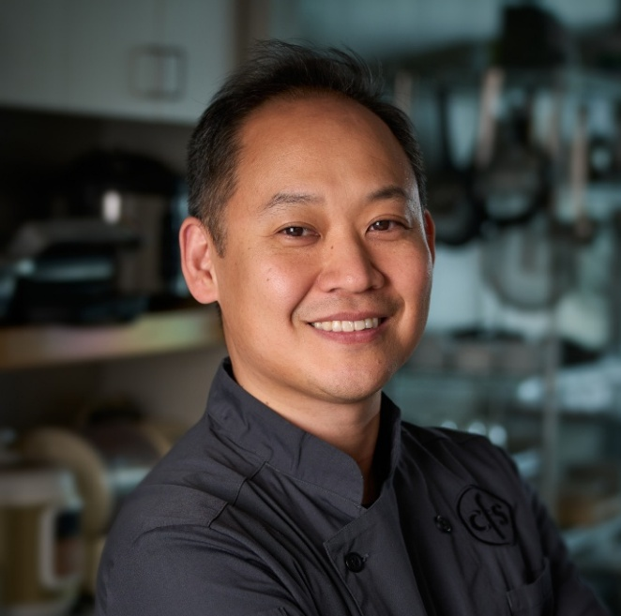
Vision Statement
My company, Creative Food Solutions (CFS), has been involved with the Research Chefs
Association since our Senior Vice President, Chef Michael Buononato has been with the
company over a decade ago. After 20 years of working in chef-driven restaurants, I joined CFS in February 2018. Every member of CFS has the option to join RCA with full company support. And during my tenure, every single member of CFS has enthusiastically joined RCA. We know the value that RCA brings to our company and to us individually.

I was curious about what it meant to be a culinologist. Having the base of my culinary career be during the glory days of the ground breaking El Bulli, modern gastronomy was always a curiosity to me. I thought that Culinology simply meant modern gastronomy. However, I soon learned that it was more than understanding hydrocolloids. The foundation of the massive food industry, to scale, was a topic that was so much bigger than I could even imagine. For the past 8 plus years, I have grown in our industry through client and peer interactions. But every year we attend the annual RCA conference, I further expand my experience within the industrial food world.

This past year, I was fortunate enough to be a judge in the student culinary competition. It was so encouraging and inspirational to meet the future professionals in our business. It was also inspirational to see how deeper the RCA has connected by being rooted in the programs of esteemed institutions like Johnson and Wales, Cornell University, and the Culinary Institute of America. Through this experience, I found myself wanting to contribute and influence how the RCA continues to grow meaningful relationships with the educational programs for our future R&D Chefs.

I strongly believe that to be called a “chef,” one must understand the foundations of hospitality. A chef understands how to nourish and create enjoyment of making something tasty. But to be a research chef, that chef must elevate to work on a different level. The foundations of hospitality are now supported through science and timeless amounts of research. If selected as a board member, I would like to work with the C&Us with Culinology programs to bring my hospitality expertise and connect how hospitality goes hand-in-hand with R&D.

Personal Bio
Chef Ben has held his own in the most storied restaurants throughout the United States. He has worked up the ladder in Philadelphia and New York landmarks such as James Beard Award winning Osteria and Michelin rated Marea, plus completing a stage in Italy’s Michelin rated Ristorante Loro. Stints at restaurant institutions such as Morimoto, LaCroix, and Per Se ultimately led him to make his own impact in the restaurant scene once he took over as the Executive Chef at A Voce Madison, receiving both Michelin and New York Times nods. After 20 years of experience as a foodservice professional, his passion for cooking led him to join the culinary division of The Food Group at Creative Food Solutions (CFS), bringing a deep understanding of consumer palates and global flavors. CFS’s long-standing membership with the Research Chefs Association has allowed Ben to further his expertise in food development on a larger scale. Ben’s active involvement with RCA has continued beyond membership. He was a Mixology Competition semi-finalist in 2020. He was one of judges for the Student Culinary Competition in 2026, is a team member of the 2026 James Beard House dinner, and the current co-chair of the Professional Culinary Competition for 2027.
Ben’s experience in food and beverage would serve a great advantage as a board member of the esteemed RCA. He looks forward to contributing his passion to further deepen the foundations that RCA has made in the world of food and beverage today. But he especially wants to contribute to how RCA will impact the future.

Mickey Miller
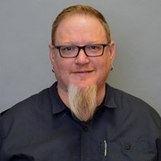
Vision Statement
I joined the RCA in 2015 with no expectations. I had no idea who RCA was. I say “who” because RCA is the people as much as the idea. During the first conference, I fell in love with all things RCA: the overall social environment, diversity, trend awareness, and of course Culinology.
What I love most about the RCA is the blend of culinary and science (Culinology) and the people involved. This great community of companions created within the RCA from students to members all the way up to the Executive Committee has made us strong and valuable to the food industry. We continue to grow strong as an organization, and each of us have things to offer. Everyone here has a unique story, and I take pleasure in taking the time to find out as many of those stories as possible. RCA is a wonderful resource that helps me reach my professional goals, establish a strong network of companions, and feeds my curiosity for what comes next.
It is always a great opportunity to bring more science through members and content to this already great group of Chefs and Scientists. My goal is to continue extending support to those who have provided the same to me over the years by giving back to the new and old members of RCA. In doing so we will all grow to become better stewards to this wonderful community and deliver great tasting, quality food that is always safe and on trend. I believe my extensive knowledge in processing and food science continues to support that goal.
I would love to serve another term supporting the members and continuing the work we are doing to preserve and strengthen the RCA. Regardless, I will be here for support as all of you have been for me.
Personal Bio
I spent several years working for a mechanical contracting company in my previous life. During that time, I was installing food processing equipment, related piping, controls, etc. I was responsible for building the pilot plant at Bush Brothers & Company which led to a position in the engineering group as pilot plant maintenance.
Shortly after, I returned to school and obtained a bachelor’s degree in food science & technology with focus on business and technology at The University of Tennessee.
After graduating, I moved from Engineering to Product Development. Since then, our company has been exploring flavorful new avenues that promote mainstream consumption of vegetable protein…eat more beans! Within my tenure at Bush Brothers, I have gained extensive knowledge in thermal processing, process improvement, and product development. I currently manage the development of several new products internally and with co-manufacturers. I am deeply involved with every step from ideation to commercialization including market research, product development (product and packaging), quality, food safety, and regulatory.
I have served 4 non-consecutive terms on the RCA board where I have been blessed with opportunities during the good times and the hard times to plan conferences and build membership engagement. I love watching the RCA bounce back with continued growth. I am proud of the work we have done and cannot wait to see what comes next! I previously served as President on the local IFT Section Board (2010 – 2016).
My personal interests include spending time with the family, teaching my adult kids to be useful in the kitchen, and how to build and fix things. I enjoy strengthening my skills in culinary arts, riding my Street Glide, and golfing when possible.

Chris Moyer
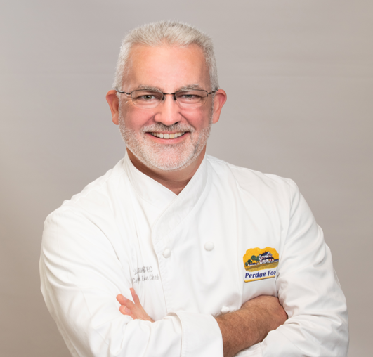
Vision Statement
My vision is to help shape the future of food by bringing together culinary craftsmanship, consumer insight, technology, and disciplined product development. RCA gave me a professional identity and a network of peers, and serving on the Board of Directors is how I return that investment — strengthening the value RCA provides its members, expanding education and engagement, and elevating the credibility and industry recognition of RCA credentials.
I would keep Culinology central as the industry evolves. The blend of culinary arts and food science is RCA’s differentiator, and I want to see it advanced in practice, not just in principle.
I am especially committed to strengthening the pipeline of talent. Students and early-career professionals need visible pathways, mentors, scholarships, leadership development, and credentials employers recognize. I would also build stronger partnerships among chefs, food scientists, educators, manufacturers, suppliers, and customers to advance collaboration and innovation.
Above all, I would represent the working chef, bringing the daily reality of the bench and the kitchen into every board conversation — practical experience, thoughtful leadership, and a forward-looking perspective that strengthens RCA and prepares the next generation to lead.
Personal Bio
Chris Moyer is the Corporate Executive Chef for Perdue Farms, Inc., in Salisbury, Maryland, where he brings a lifelong passion for food, hospitality, and culinary innovation. A 1991 graduate of the Culinary Institute of America, he built his classical foundation with the Ashley Hotel Group, the Inn at Perry Cabin in St. Michaels, Maryland, and Llangoed Hall in Wales, followed by chef roles in Beaufort, North Carolina, and Key West, Florida.
In 2000, he moved into the foodservice equipment industry, spending five years as a culinary leader for major brands and helping chefs across Maryland, D.C., Delaware, and Virginia improve food preparation and kitchen performance.
At Perdue, Chris leads culinary strategy and product development across Retail and Foodservice — tracking flavor trends, setting product gold standards, and running ideations for some of the world’s largest food brands. His work spans bench development, benchtop-to-plant scale-up, and cross-functional launches with food science, sourcing, and marketing partners, delivering concepts that meet real cost, shelf-life, and operational constraints. Whether he’s in Perdue’s Innovation Center, with customers, or on the road at culinary events, Chris stays motivated by turning an idea into a product or experience for others to enjoy.
Chris also serves on the Board of Directors of the St. Michaels Community Center, which provides up to 500 meals a week. He led the team that redesigned the Center’s kitchen as part of a $4 million renovation and is working to launch a workforce program that teaches young adults to cook and places them in jobs at local restaurants.

Laurie Neff

Vision Statement
When people ask me what I do, I tell them I feed the world. That's my purpose, and it's why I've spent my career at the intersection of food and commerce — moving from national accounts at Heinz and HP Hood, through sales and customer experience leadership at Griffith Foods, to my current role as Chief Revenue Officer at Tulkoff Foods. Across brand, private label, retail, foodservice, and ingredients, I've built my reputation on one belief: great products only matter if the business behind them is built to last.
I joined RCA because it was a rare community where culinary creativity and food science rigor carried equal weight. Throughout my career, I've been part of that partnership — the commercial voice at the table with Research and Development, Innovation, and Culinary teams, turning good ideas into products built to last. RCA has remained a vital thread of connection across every stage of my industry journey, not because it added a line to my resume, but because its mission mirrors what I care most about: helping food professionals innovate faster and smarter, together. I've been an engaged member — following the association closely and applying its thinking in my own commercial work — and I'm ready to turn that ongoing connection into active board service.
If elected, I want to champion Stability: RCA's long-term financial health and organizational sustainability. I've spent 20+ years building and protecting P&Ls of significant scale, leading through mergers, integrations, and organizational redesigns, and turning fragmented commercial functions into disciplined, scalable ones. At Lakeside Foods, I built shared-services structures that aligned resources to long-term goals across multiple business units; at Griffith Foods, I led complex multi-stakeholder projects spanning commercial, R&D, and operations teams across key global customers. That is precisely the discipline RCA's Board needs to safeguard its future.
I'm uniquely positioned for this role because I bring an outside-the-building perspective few culinary-science boards have: a career built entirely on commercializing food innovation at scale, across every channel from QSR to retail. Beyond my professional work, I lead with service — as a mission trip leader and longtime volunteer with purpose-driven organizations including BLUE Missions — and I'll bring that same commitment to RCA, ensuring the organization stays financially sound and mission-focused for the members building the future of Culinology. My experience turning culinary innovation into durable commercial success is the lens I would bring to the Board — pressure-testing strategy against real market dynamics and building the financial rigor that lets RCA's ambitions scale.
Personal Bio
Laurie Neff has built her career at the intersection of food and commerce on a single belief: great products only matter if the business behind them is built to last. She serves as Chief Revenue Officer at Tulkoff Foods, where she owns the enterprise P&L and leads commercial strategy, sales organization, and go-to-market execution for the company's customized liquid food solutions business.
Prior to Tulkoff, Laurie was Senior Vice President at Lakeside Foods, where she built shared-services structures that aligned resources to long-term goals across multiple business units, subsidiaries, and joint ventures, delivering 10% year-over-year net sales growth. Earlier, at Griffith Foods, she managed complex, cross-functional projects and led category management that strengthened contribution margin across key global customers. She has also held senior leadership roles at SupHerb Farms, Campbell Soup Company, Heinz North America, HP Hood, and Basic American Foods, turning fragmented commercial functions into sustainable growth engines across brand, private label, retail, and foodservice channels.
Throughout her career, Laurie has specialized in building high-performing commercial organizations, leading M&A due diligence, implementing disciplined revenue management and forecasting, and forging partnerships that expand market share. Her leadership blends financial discipline with a people-first approach to organizational change, and she has built and led teams as large as 300 professionals.
Laurie holds an MBA in Organizational Development from Northern Kentucky University, and her professional certifications include Challenger Sales I & II, Miller Heiman Train-the-Trainer, Rapport Leadership International Levels I & II, and Korn Ferry Leadership Architect.
Laurie has long been an engaged member of the Research Chefs Association, drawn to its mission of uniting culinary creativity with food science rigor — a partnership she has seen firsthand between R&D and commercial teams. Beyond her professional work, she is active as a mission trip leader and volunteer with her church and BLUE Missions.
Taken together, Laurie brings to the RCA Board proven financial stewardship, enterprise-level P&L experience, and a track record of building organizations for long-term stability — precisely the discipline needed to safeguard RCA's financial health. Her career-long fluency in commercializing food innovation, paired with her deep respect for the culinary science that makes it possible, positions her to be an effective, mission-driven voice on the Board.

Casey Schallert
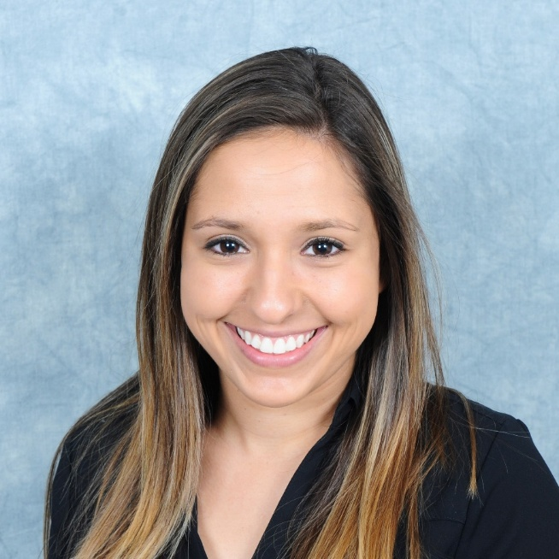
Vision Statement
RCA has been an important part of my professional journey since I joined as a student at The Culinary Institute of America. The relationships, experiences, and opportunities I've gained through this organization have helped shape my career, and they continue to inspire my passion for serving our members and advancing our profession.
During my time on the Board of Directors, I have been honored to serve the Association in new ways, including being elected to the Executive Committee as Secretary. I have also worked closely with the Student and Young Professional Committee to strengthen engagement through improved communication channels, increased opportunities for participation, and the development of a sponsorship program that helps students connect with and learn from industry professionals. In addition, I supported in the development of the RCA Future Leaders Program to create meaningful pathways for leadership development and prepare the next generation of volunteers and industry leaders.
As I look to the future, my vision is to help RCA continue to grow, evolve, and create meaningful value for every member. I believe our greatest opportunity lies in expanding membership, strengthening engagement, and ensuring that members at every stage of their careers view RCA as an essential resource for learning, networking, leadership development, and professional growth.
I want future members to experience the same sense of connection, opportunity, and inspiration that I found as a student. By investing in emerging leaders, enhancing the value of membership, and maintaining the strong community that bridges culinary arts and food science, we can ensure RCA remains the premier organization for food innovation professionals.
RCA has given me so much throughout my career. My goal is to continue giving back by helping build an even stronger Association for the next generation of research chefs, culinologists, and industry leaders.
Thank you for the opportunity to serve. I would be honored to continue contributing my passion, experience, and dedication to the future of the Research Chefs Association.
Personal Bio
Casey is a research and development professional with over a decade of experience spanning culinary arts, food science and innovation. She currently holds the title of VP of Culinary at Midas Foods where she is responsible for new product development, culinary innovation, and strategic planning. She has previously held positions at Bell Flavors and Fragrances & Nutek Food Science where she developed a robust background in ingredient applications, culinary sales demonstrations and innovation.
She has demonstrated the ability to drive business growth and foster innovation across a wide range of products. Her career is defined by her ability to blend technical expertise with creative innovation. In addition to her professional achievements, Casey holds an Associate's Degree in Culinary Arts and a Bachelor's Degree in Culinary Science from the Culinary Institute of America. She also holds a Master’s Degree in Food Science from Kansas State University and currently sits on the Board of Directors and Executive Committee as the Secretary for the Research Chefs Association.

Cara Watkins
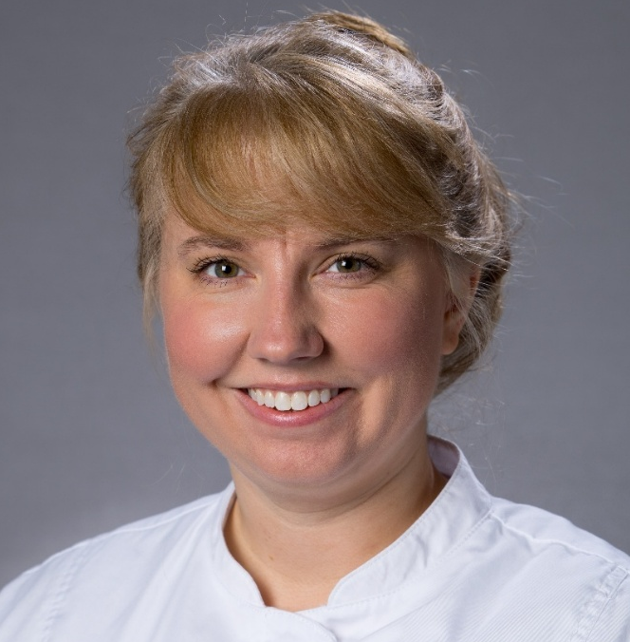
Vision Statement
My RCA journey began during my freshman year at college when a simple question changed the course of my career: "What do you want to do for a living?" I knew I loved baking, and that passion led me into the food industry and ultimately to the profession that perfectly combines culinary creativity with food science.
After earning degrees in Hospitality Management, Baking & Pastry, and Culinology, I built a diverse career spanning fine dining, culinary education, ingredient applications, and food manufacturing. Along the way, I discovered the Research Chefs Association and found a community that embodied the same cross-functional collaboration that has shaped my professional journey.
Today, I serve as an R&D Research Chef at Blommer Chocolate Company, where I have the opportunity to combine my expertise in baking, pastry, chocolate, and product development. In 2024, after years of professional growth and preparation, I achieved my goal of becoming a Certified Research Chef, a milestone that reinforced my commitment to the profession and to RCA.
Service and community involvement have become increasingly important throughout my career. As a board member of the Chicagoland AACT, I have witnessed firsthand the value of professional organizations in creating meaningful connections, supporting career growth, and fostering industry engagement. I have also supported events hosted for regional AACT, IFT, and RCA professionals, and I am honored to participate in this year's RCA James Beard House dinner. These experiences have strengthened my desire to give back to the community that has helped shape my career.
As a member of the RCA Board of Directors, I will bring a unique perspective rooted in baking and pastry expertise, food manufacturing, and leadership within the confectionery industry. I am passionate about increasing member engagement, supporting the next generation of research chefs, and creating opportunities for meaningful industry connections. I believe my collaborative leadership style, board experience, and enthusiasm for service will allow me to make a positive impact on both the board and the organization.
RCA has played an important role in my professional development, and I am excited about the opportunity to help guide its future while ensuring it remains a vibrant, supportive, and innovative community for research chefs and professionals at every stage of their careers.
Personal Bio
Cara Watkins is a Research & Development (R&D) Chef & Scientist at Blommer Chocolate Company with over 17 years of baking and pastry and 11 years of R&D experience. She is a Certified Research Chef with multiple degrees including an A.A.S. in Baking and Pastry Arts, a B.A. in Hospitality Management and a B.S. in Culinology.
Throughout her career, Watkins has worked at widely recognized fine dining establishments both in Chicago and in France. She interned under chef Simon Scott at Michelin-starred Bistrot Saveurs, at the Peninsula Hotel and Union League Club of Chicago and alongside her studies, she joined the pastry team at Everest Restaurant, which garnered recognition worldwide, from the James Beard Foundation, Michelin Guide, Relais & Chateaux, and Les Grandes Tables Du Monde.
Watkins took her passion, experience & love for fine dining pastry beyond the restaurant and into the classroom where she served as a Teaching Assistant for the pastry students at Kendall College before moving into other sectors of the food industry.
The culmination of her education & experience led Watkins from back of the house to research and development positions at Tone Products, VJI, Flavorchem and now, Blommer Chocolate Company. At Blommer, she has found the perfect harmony of baking, pastry, and research and development.
In addition to her day-to-day responsibilities at Blommer Chocolate Company as a Research Chef, Watkins was on the 2025 planning committee for the annual R&D technical summit to ensure a smooth and fun week for 30 people. Watkins has presented at tradeshows such as Sweets and Snacks as well as Retail Confectioners International. She currently servers on the Chicago section of the America Association of Candy Technologists (AACT) board as membership chair. Watkins has competed twice in the AACT iron confectioner’s challenge and was on the winning team in 2024. During the 2025 RCA James Beard House event, Watkins supported the dinner by providing a variety of Juila Child themed bon bons and has been selected for the 2026 culinary team, providing the main dessert.

